Delta Kappa Gamma
Alpha Iota Chapter Meeting Agenda
Monastery of the Holy Spirit,
Conyers, Georgia (www.trappist.net/)
May 4, 2013
“Forward Moving Together Thinking of Faith”

9:30 AM Light Brunch: may not be needed
10:00 AM Meeting
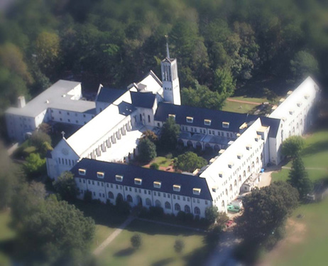
Welcome and Call to Order by Anita Thomaston, President
Inspiration:
Roll Call and Remembrance Notecards
Minutes: Donna McDonald
Communications: Debra Anderson
Treasurer’s Report: Merry Greenwood
Old business
New business
Announcements
Committee Reports
Program: Road trip to the Monastery in Conyers (arranged by Cindy Thompson), Includes tour, Laura Michelle Woods will check on a bus.
Service Project: Rainbow House—bring summer activity supplies or perhaps scholarships for kids to Arts Clayton Camp (Cheryl Goff will give us details about needs.)
Door Prizes: Cathy Schreiber
Adjournment of Meeting
Lunch: at the Monastery or a local restaurant (to be decided)

