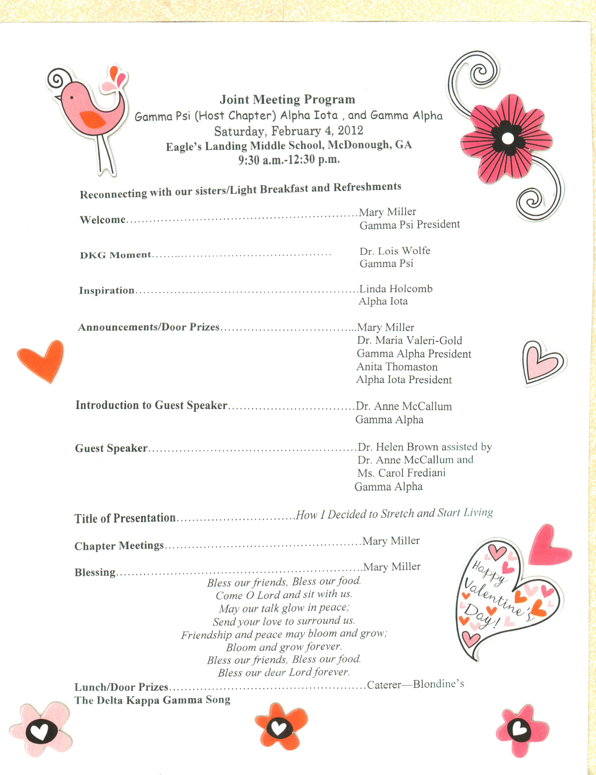

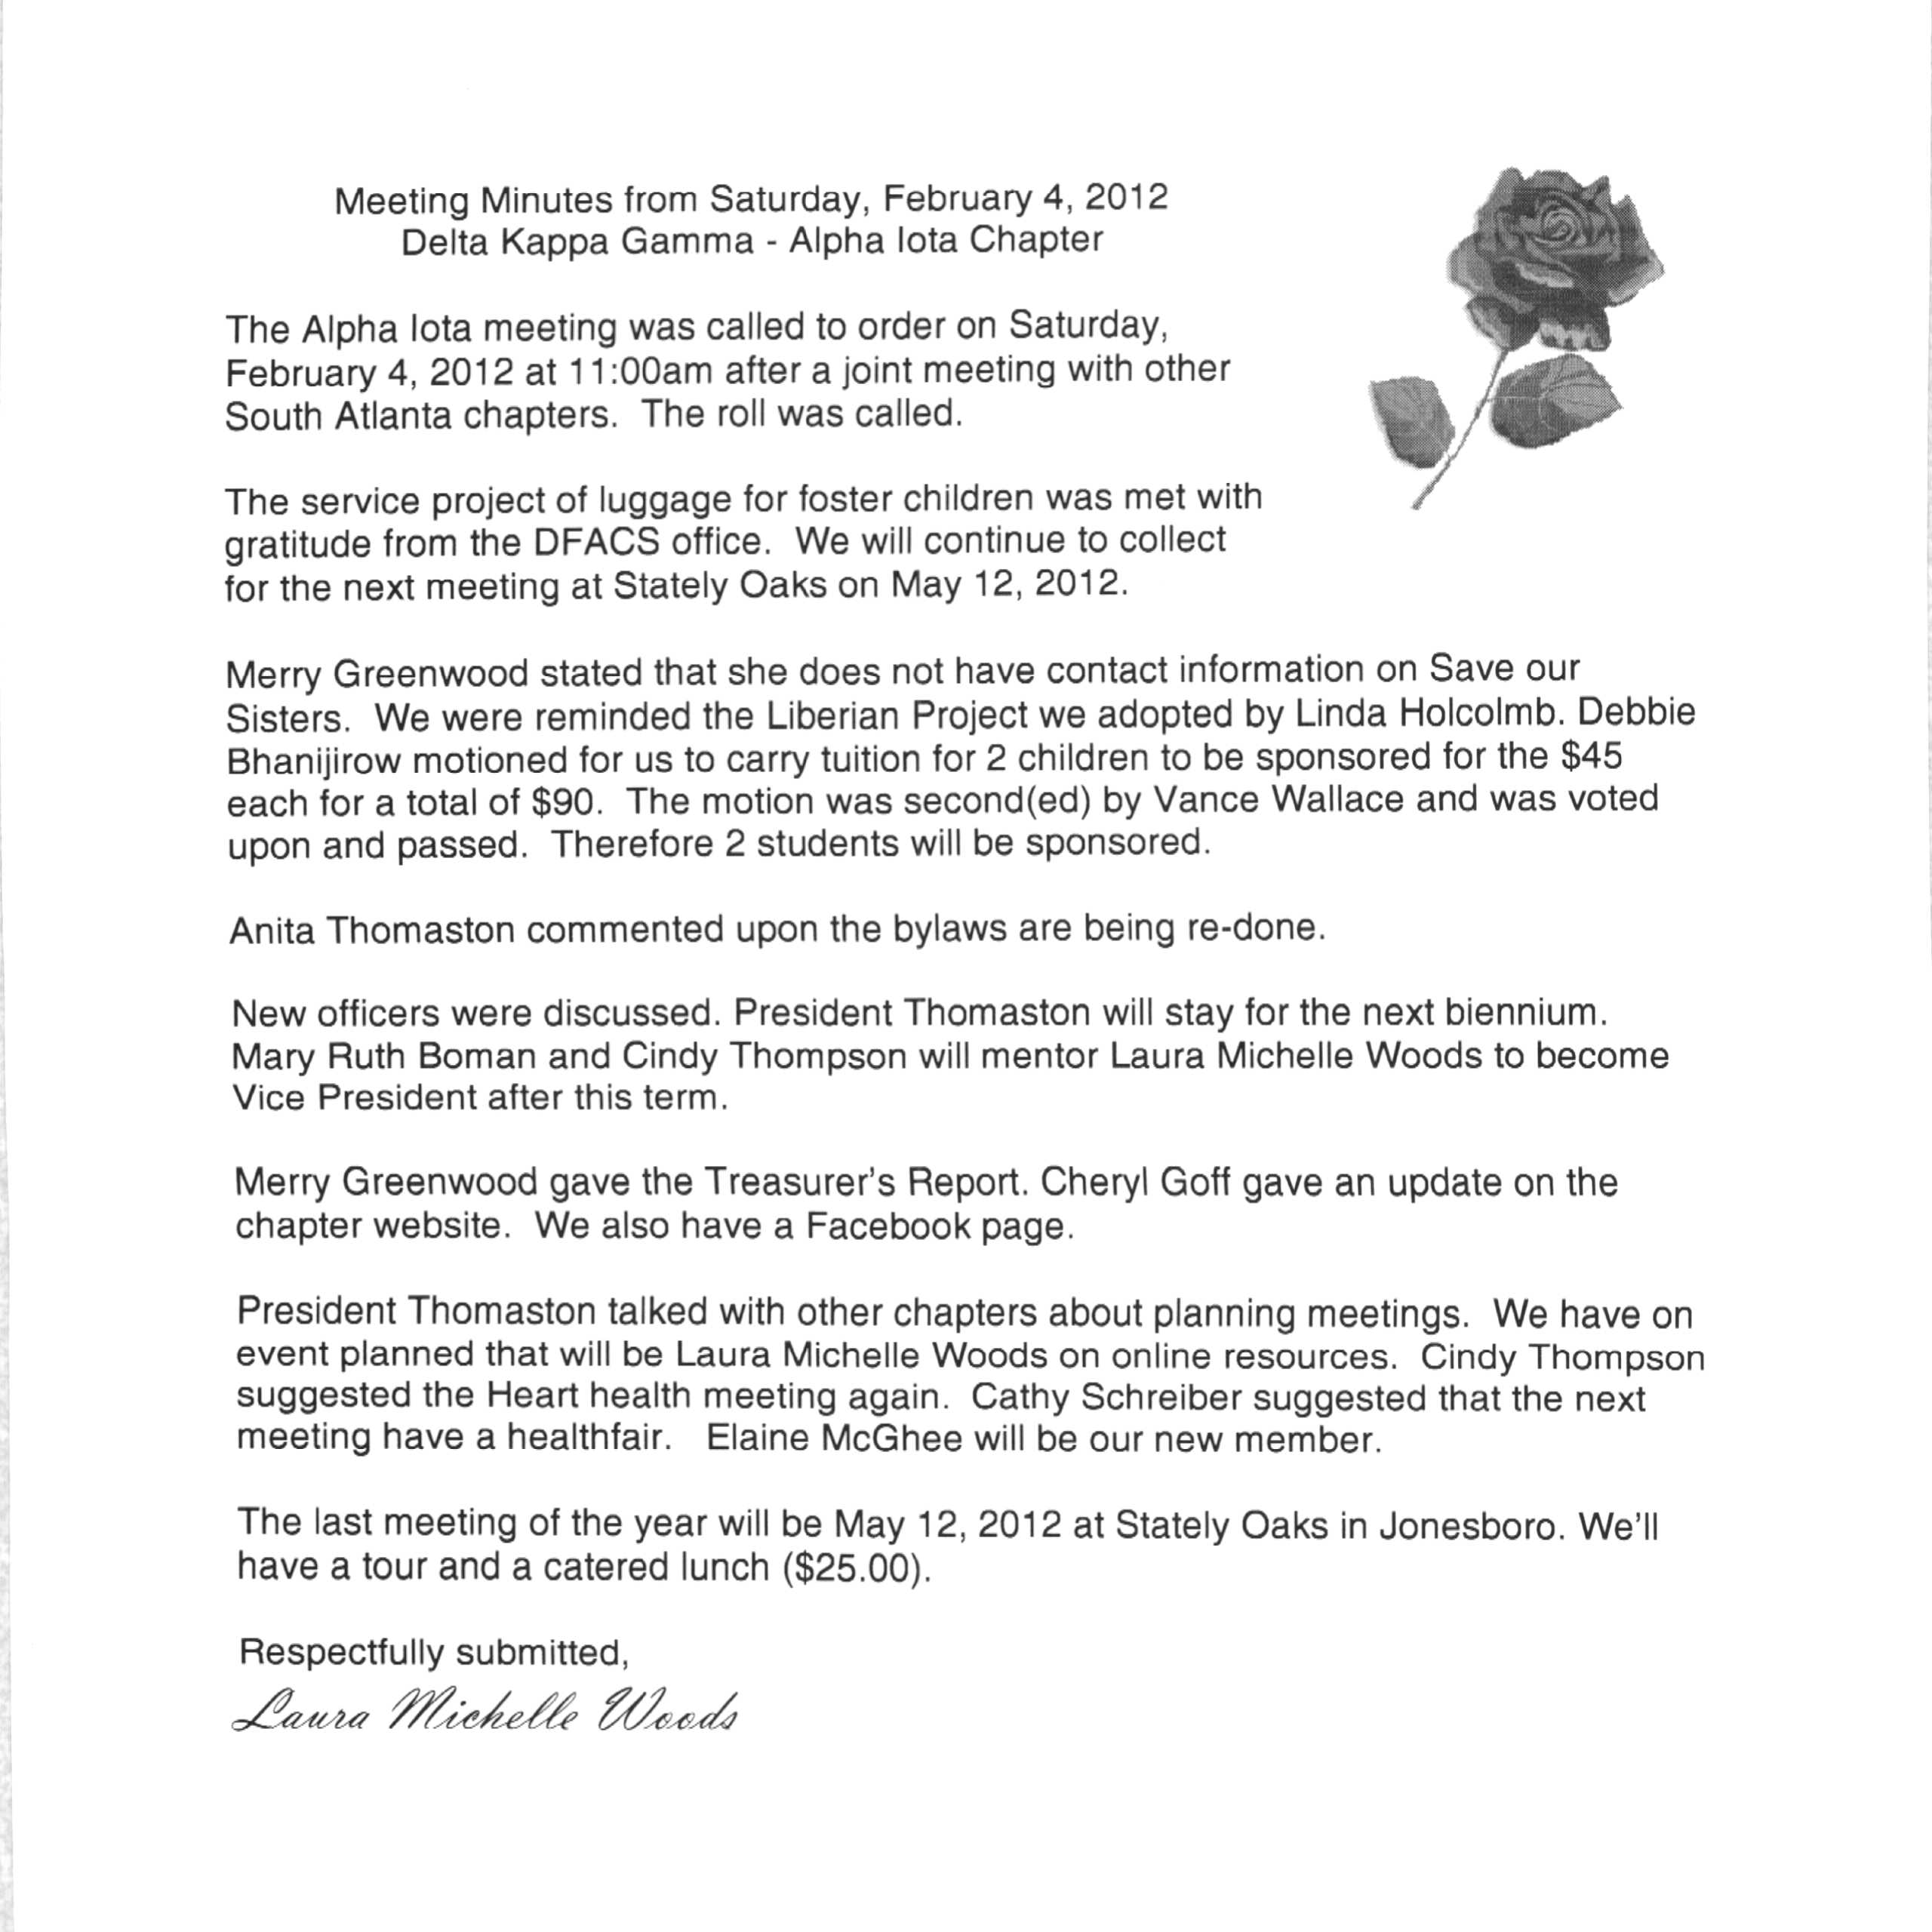

Alpha Iota Treasurer’s Report
February 4, 2012
12/02/2011 Balance on Hand $4164.83

Deposits
12/07/2011 1462.50
Lunch - $13.00
Dues – $915.00
Auction – $5/34.50
Expenditures
12/03/2011
Morrow UMC/Fellowship Hall 50.00
Debra Anderson/stamps and cards 16.08
Mary Ellen’s Personal Touch Catering 323.75
Anita Thomaston/poinsettia for Ethel Jewett 10.00
12/05/2012
State/International dues 1399.18
Award Concepts/new member’s pins 40.81
02/05/2012
Balance on Hand $3787.51

